Senior Design Project 9
Generic Armored Vehicle Power Control Handle
Concept Generation and Selection

Client:


October 14, 2010

Group 9:
Michael D. Brown
William Thornton
Deanna McKenzie

Table of Contents
Introduction………………………………………………….…………………………………………………………..…………………………2
Design Concepts for Steering Sensors…….…………………………………………………..………………………………………..2
Concept 1: Resistant material conduction……….……………………..……………………………………2
Figure 1……………………………………………………………………………………………….2
Concept 2: Small Potentiometer…………………………………………………….……………………………3
Figure 2…………………………………………………………………………….…………………3
Figure 3…………………………………………………………………………………………….…3
Concept 3: Car Steering Wheel sensor…………………………………………………………………………4
Figure 4………………………………………………………………………………………………4
Summary…………………………………………………………………………………………………………………….4
Table 1………………………………………………….....………………………………….……5
Design tools for Haptic Response……………………………………………………………………………………………………….5
Vibration…………………………………………………………………………………………….……………………………6
Figure 5……………………………………………………………….…………………………………6
Figure 6……………………………………………………………….…………………………………6
Force Feel………………………………………………………………………………………………………………………..6
Friction……………………………………………………………………………………………………………..……………..7
Figure 7…………………………………………………………………..……………………………7
Design Concepts for Adaptable Handles……………………………………………………………………………….……………7
Removable Grip Covers……………………………………………………………………………………………………7
Figure 8………………………………………………………………………………………………..8
Replacement Handles……………………………………………………………………………………………………..8
Figure 9…………………………………………………………………………………………………9
Concept Comparison……………………………………………………………………………………………………….9
Conclusion…………………………………………………………………………………………………………………………………........10
Sources……..………………………………………………………………………………………………………………………………………11
Introduction
Lockheed Martin currently makes an Advanced Gunnery Training System (AGTS) for the purpose of training troops to operate armored vehicles for the military. As of right now, this training system consists of many different types of heavy handles that currently lack the “feel” of the armored vehicles they are supposed to be mimicking. Our main goal is to design a generic gunnery trainer handle that is both lightweight and compatible with many different simulations. We hope to have a lightweight, fully functional handle with the proper type of feel and an assortment of different “settings” to accurately mimic the armored vehicles’ motions.
Design Concepts for Steering Sensors
Sensor Introduction:
The first concept that utilizes the principle of reading a change in voltage uses a large piece of material with a measurable resistance. As can be seen in Figure 1 below, this material wraps around the shaft a full 150 degrees; the full angle rotation required by the client. There is a wire connected to one side of the material with the other end connected to a voltmeter. Another wire connects the voltmeter to a swinging arm which is rigidly attached to the turning shaft. The voltmeter will then be able to measure the voltage across the resistive material. As the control handle turns, so does the shaft. This moves the swinging arm across the resistive material, either increasing or decreasing the resistance. This is in essence a large version of a variable resistor, or a potentiometer. As a side note, some materials that can be used for the resistive material are a doped carbon material, a ceramic-metal composite, or a conductive plastic material.
Concept 1: Resistant material conduction
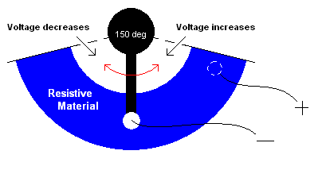
Figure 1: Drawing of resistive material conduction design
This design has many plus sides, one of which is its simplicity. The only moving part is its swinging arm, which is rigidly connected to the shaft. This means that there is no conversion between the angle that the shaft moves and the angle that the swinging arm moves. Another good thing about this design is that it uses very few parts. It uses a swinging arm, two wires, and a curved resistive material. Although this design is promising, it still has some flaws. Firstly, with the exception of the wires, the other parts will have to be fabricated. Even though this is not an insurmountable hurdle, it adds to both the cost and time to this design. Unless common prefabricated materials can be used, these problems will be a base concern going forward from this design. Secondly, this design may be on the large side. Even though there is room in the plastic shell bodies that contain the shafts, it would be easier to use a smaller component.
Concept 2: Small Potentiometer
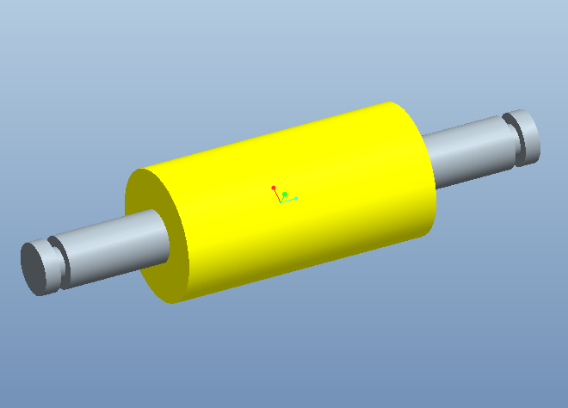 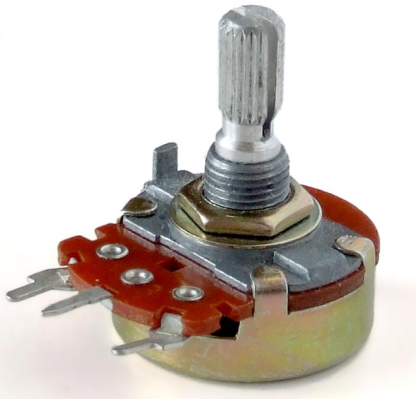
Figure 2: Snap in Roller Figure 3: Small Potentiometer
The second concept for the sensing capabilities of the gunner’s handle utilizes the components seen in Figures 2 and 3. Figure 2 shows a small roller like one might see inside a mouse that uses a trackball instead of a laser. These mice have two small rollers that can register the direction of the roller ball’s movement, and its rotation velocity as well. Figure 3 shows a common potentiometer that can be purchased at any electrical component store. This potentiometer, like the larger one is Concept 1, measures a change in voltage when the rotation arm is twisted. The simulator can then read this voltage change as a change in the steering shaft’s angle. The idea is that the rollers would snap into part of the skeleton design next to whichever steering shaft it is measuring. The axis of the roller will be connected to the rotation arm of the potentiometer, meaning that when the roller is turned by friction with the shaft, the potentiometer’s rotation arm is also turned, changing the voltage reading. This design may need to use gears, if the contact between the shaft and roller doesn’t provide enough friction.
The best part about this design is the fact that all of its parts are cheap and can be purchased quickly. If the roller can be integrated into the plastic outer shell of the handle, it is also extremely easy to install and replace. One downside to this design is the implementation of a more complicated potentiometer. This potentiometer utilizes more parts than the previously proposed component, which means that there are more parts that can break. However, this problem may be outweighed by the ease and affordability of replacement. Also, this design is moderately more complicated because of the difference in the angular displacement of the roller and the shaft itself. Lastly, it may be necessary to recalibrate this design often, because the design assumes no slip between the roller and the shaft.
Concept 3: Car Steering Wheel sensor
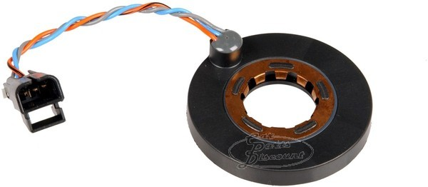
Figure 4: Steering Wheel Sensor
The last of our ideas for sensing methods involve the implementation of a common steering wheel sensor. This would be an extremely easy solution to a complicated problem because it is a one component installation process. The main idea is to simply slip the steering wheel sensor around the shaft whose rotation is being read before it is installed. Like the other concepts, this idea is basically a potentiometer which gives a voltage difference in response to rotation.
This design would be an ideal solution to the problem of sensing shaft rotation because of the devices durability and easy installation, but the installation could become more complicated depending on the steering wheel sensors turning resolution. Most steering wheels are designed to have a full angle turn around 1400 degrees, meaning that our steering wheel (150 degrees full angle) isn’t using the entire capability of the steering sensor. Since the sensor was made to read large full angle turns, the resolution for 150 degrees of turn might be quite low. The installation complication arises when trying to fix this problem. Something like a gearing system would have to be implemented. The sub-components of the steering sensor will complicate any repair that is necessary, but since these sensors cost on average around $30 they can be replaced cheaply. The installation, although difficult, would not need to be done very often since these components are made to be rugged.
Summary
In comparison, all of these components have their pros and cons. Concept 1 is simple, and yet it uses materials that will probably not be readily available. It is a very straightforward design and doesn’t need any sort of gearing system to account for low angle resolution. Its installation, although easy to implement, makes for difficult replacement of parts. Concept 2 involves two basic, simple components that are both easily bought and installed. These components are readily available in most places. This concept is designed to use friction with the shaft to turn the potentiometer, but it may be necessary to use gears. Even though it’s simple, the small potentiometers used may not be as durable as needed. This however may be offset by the fact that they’re inexpensive. Concept 3 is both durable and has only one part that needs to be handled. This one component has many subcomponents which heighten the likelihood of malfunction, but this may not be a problem because steering wheel sensors are made to be rugged. This design would also be more difficult to install than the other two, but this may be outweighed by its durability, meaning it won’t have to be replaced often.
Table 1: Decision Matrix
 | Importance | Concept 1 |  | Concept 2 |  | Concept 3
 | Importance | Rating | Weighted  Score | Rating | Weighted  Score | Rating | Weighted  Score
Durability | 30% | 7 | 2.1 | 6 | 1.8 | 9 | 2.7
Ease of Installation | 30% | 6 | 1.8 | 9.5 | 2.85 | 5 | 1.5
Affordability | 25% | 6 | 1.5 | 8.5 | 2.13 | 8 | 2.0
Simplicity | 15% | 7 | 1.05 | 7 | 1.05 | 7.5 | 1.13
Weighted Scores | NA | 5.48 |  | 6.88 |  | 6.45
The decision matrix was built by using ratings of importance for each engineering aspect. Durability and ease of installation ranked highest; both holding a weight of 30% each of the total score. Affordability, although important, is not quite as important as either of the first two aspects, which is why its score is only 25%. Simplicity is always important in a design, but since these concepts were scored for their relative simplicity, this weight is of lower importance. This is mostly because even though some of the designs are clearly simpler than others, they are all fairly simple to begin with. After relative scoring was done on a scale of 1 to 10 (1 = very poor; 5 = fair; 10 = excellent), those scores where then multiplied by their importance values and added together for each concept. The Weighted Scores row is the result of those scores. In the end, Concept 2, the concept which utilizes a small roller and potentiometer won for its affordability and ease of installation. Its simplicity was between the other two concepts, and its durability was below that of the other two.
Haptics
The customer specified a concept of haptics to be integrated into the design. Haptic comes from the Greek word haptikos and means pertaining to the sense of touch and descends from the Greek verb, haptesthai, and meaning contact or to touch. Haptic technology is tactile feedback technology that allows a user to feel forces, vibrations, and/or motions with their sense of touch. This mechanical stimulation may be used to assist in the creation or control of virtual objects. This group will explore and analyze the different concepts of haptics and how we might integrate it into the design.
The concept of haptics with the gunner control handle includes an idea of vibration, force feel, and friction.
Vibration
The vibration idea would be similar to a gamers’ controller such that the when the gamer hits an object in the game the remote vibrates, or a cell phone when the user touches their screen the phone vibrates to simulate a button being pressed. This will apply to the gunner’s handle also which means that when the user hits a bump or a target then the handle will vibrate. The vibration concept is the simplest and cheapest of the three with vibration motors and weights.
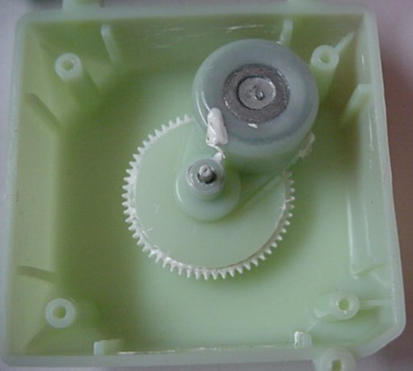 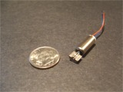
Figure 5: Vibrating motor from a Tickle me Elmo Figure 6: Vibration motor used for cell phone haptics
Force Feel
Force feel means that the force felt by the user on the handle is realistic. The handle should give an opposing force when the user encounters an obstacle in simulation. This will improve the simulation and provide an accurate learning experience.
One concept to implement the force feel we have investigated using motors to push back on the user. The motors will be controlled by a program that can respond to objects in simulation. These motors would be directly attached to the roll axis and indirectly attached to the pitch axis. The pitch axis motor will use a series of cables and pulleys in order to actuate and apply the force needed.
A draw back to the motors for force feel is the amount of space inside the handle versus the size and power of the motor. Usually the size of the motor is proportional to the amount of power it puts out. The motor controller or encoder will also have to be taken into consideration.

Friction
The concept of adding friction to the handle’s haptics consists of making the handle feel heavier than it is since it will mostly be plastic. The friction control will add a level of resistance to the simulation experience which in turn adds realism and a sense of driving a heavy object.
An idea of the friction control is trying to “gum up” the controls. In order to implement this we have explored springs to provide this resistance. The springs would be mounted in some way to each axis. Another benefit of the springs is the handle will return to its original position which is be good for encoders and reading positions on potentiometer.
Another concept is using Flexinol wire, a metal wire that contracts when heated and expands when cooled off. This wire would be attached to each shaft and electrical wires on each end of the Flexinol wire to provide heat, the Flexinol will contract and give a resistance to the user. The biggest advantage of this wire is the cost; the flexinol is about $3.00 per meter. This wire is also a space saver; if space is limited inside the handle then this would be the best choice.
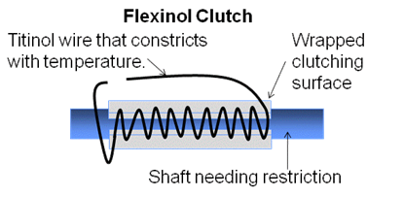
Figure 7: Flexinol wire
Design Concepts for Adaptable Handles
Removable Grip Covers
The first concept, pictured below, is based on having one adjustable centerpiece with a set of handles permanently attached. Since the handles are permanently attached to the center body the grips must be interchangeable. The main idea is to have an entire set of removable grips that can be easily slid over the handle. The advantages of this design are in the simplicity. This design can be changed from on form of machinery to another by simply sliding one set of grips off of the generic handle and replacing them with the appropriate grips. This design easily accomplishes our goal of making a generic trainer that is easily interchangeable for several different training simulations. Another extremely advantageous part of this design is that production of multiple handle configurations can be accomplished by simply making an inexpensive adaptable polymer grip. The replacement grips can be attached through a large variety of simple mechanisms, such as having some form of snaps that fit the grip to the generic handle. The attraction to this design comes from its overall simplicity and it’s relatively low cost of producing multiple grip configurations.
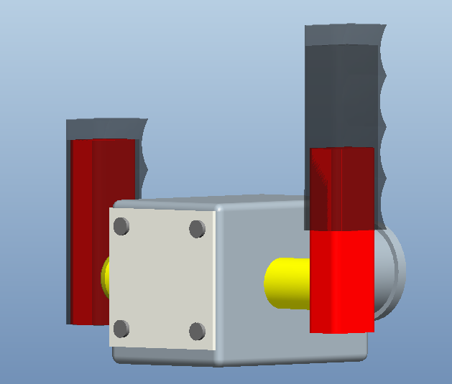
Figure 8: Permanently mounted handle with removable grip cover
However, like every design there are several inherent disadvantages. The greatest obstacle to overcome if we were to make this concept a reality would be to create a realistic “feel” for each of the different vehicles the trainer is to represent. To accomplish this goal would require the addition of a variable force application to all of the shafts that will resist steering forces in a similar manner as the vehicle it is to represent. While this matter mostly deals with haptics, it incorporates a significant cost to the concept of interchangeable grips that slide over a generic handle. A second issue that arises with this concept is the integration of buttons on the handle. Not all vehicles these simulations emulate have exactly the same button configuration on the handle. The buttons used for firing and other operations can have several different mounting points. With the generic permanently mounted handle it would become quite challenging to make a variable trigger placement. While this design concept is very easy to use interchangeably between vehicles and new grips would be inexpensive to produce there would be significant cost to the design process, to account for these issues.

Replaceable Handles
The second concept to make the center body of the trainer interchangeable between vehicles is to use replaceable handles, as seen below. By using a center body that allows the handles to be added and removed with relative ease the handles could easily be designed to represent the desired vehicle. Each removable handle would incorporate a mechanism to imitate the general frictional response to oppose steering inputs that are accompanied by the vehicle it represents. This removes the need to design a variable feel response system that can be adjusted for each type of simulation. This concept would also make replication of all buttons and triggers on the handles possible, with relative ease, making replication of the look and feel of every vehicle that is to be simulated plausible.
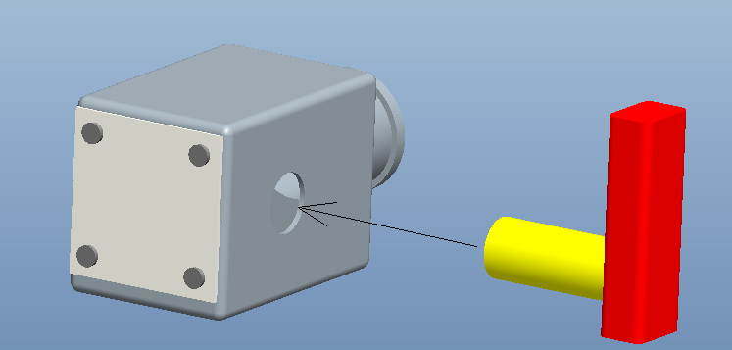
Figure 9: Removable Handles
The concept for this design sounds simple; however, there are many glaring issues that must be dealt with to make this design feasible. The two main concerns with this design are the cost and complexity. The cost of producing many handles would be very expensive, because all handles would include full grips, a friction feel device, a set of handles, and a set of buttons. Compared to other concepts that require nothing more than a change of grip covers to switch between vehicle simulations, this concept is also quite complex. This design would also require the addition of an extra attachment to connect the wiring from the handle to the center body of the trainer. The addition of connections into the design makes the wiring more susceptible to exterior elements. The more connections and interfaces between wires, the greater the possibility of failure in the wiring. This design would require some mechanical means of detaching and attaching the handles, and it would also require an extra electrical interface to connect the buttons from the handle to the center body.

Concept Comparison
While both concepts would potentially work to accomplish our goal of creating a generic gunnery trainer center body, that is easily interchangeable between vehicle simulations, both designs are different in many ways. The main advantages of the first concept are the simplicity of changing grip configurations. The second idea however is relatively complicated to alternate between vehicles. The production cost of creating auxiliary grip configurations, for the second concept, is many times higher than the cost of producing the additional grip covers that are used in the first concept. When examining only production costs and ease of variability the first concept is far superior to the second concept in every way.
However, production cost is not the only component taken into account in the design process. The complexity of the design can also represent a large portion of the design selection. The second design incorporates a much simpler mechanism to adjust the frictional feel that opposes steering, because the frictional response can be customized to each handle configuration and integrated into each different handle; whereas the first design requires the fabrication of a device to supply a variable friction force to the handle, so that it can be adjusted for each grip configuration. The first device also requires some engineering a way to create the appropriate button configuration for each vehicle, and since the handles are permanent the buttons must either be generically placed or integrated into the removable grips. Both designs have very distinct advantages and disadvantages when evaluated against one another, we must rely on a decision matrix to find which concept best fits our criteria.
Conclusion
Further discussion is needed in order to pin down the ways in which type of haptics will be utilized in our design. We have briefly outlined different methods that can be used to meet the requirements of many different haptic responses. Haptics have a large range of pricing options for a wide range of complexity, making the decision for their use a fairly difficult problem. When coming up with our criteria for the adaptable handle, the haptic response of the system became a key component. Since we were unable to finalize the haptics to be used in our final design; selecting a mechanism for making the handles interchangeable was nearly impossible. Although we were unable to decide on a concept; we are looking into the haptic response necessary to fully emulate the appropriate vehicle response, and will then be able to finalize our concept selection.

Sources
Haptics
Gabriel Robles-De-La-Torre. "International Society for Haptics: Haptic technology, an animated explanation" <http://www.isfh.org/ch.html.>
"Robles-De-La-Torre G. Virtual Reality: Touch / Haptics. In Goldstein B (Ed.), "Sage Encyclopedia of Perception". Sage Publications, Thousand Oaks CA (2009)."
Figure 3
http://upload.wikimedia.org/wikipedia/commons/b/b5/Potentiometer.jpg
Figure 4
https://www.carpartsdiscount.com/auto/archive/pictures/44276/600/1/P/2CA4435/oldsmobile_intrigue_01_steering_wheel_speed_sensor_oem_26064468.jpg
Figure 5
http://electronics.howstuffworks.com/question368.htm
Figure 6
http://pocketnow.com/thought/how-does-a-cell-phone-vibrate
Figure 7
Courtesy of Steve Preston (behalf of Lockheed Martin)

